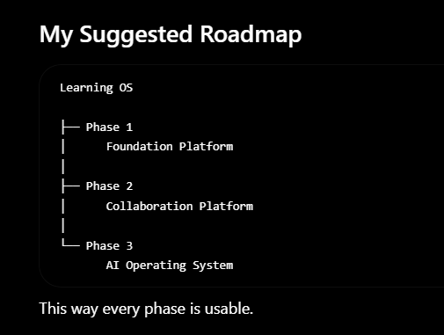
PHASE one ;
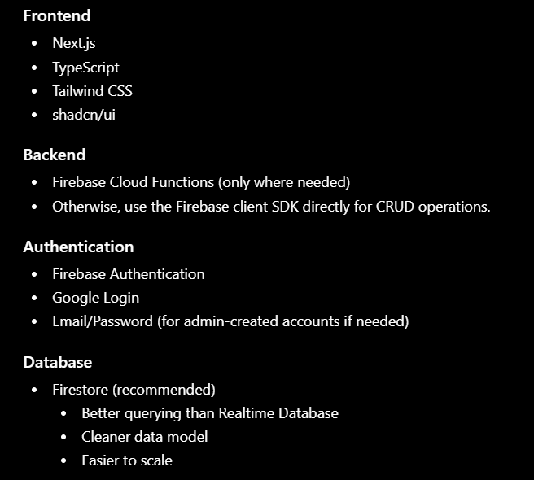
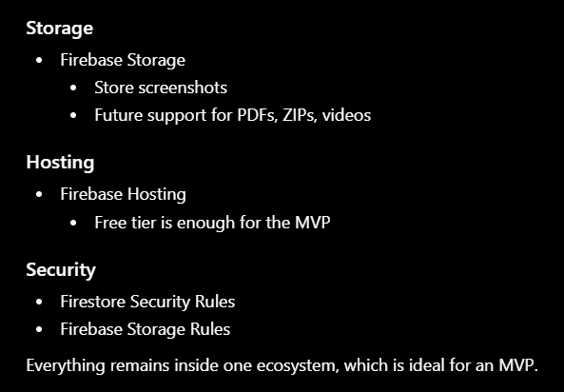

docs/
INDEX.md
01-Product/
├── 01-Product-Vision.md
├── 02-PRD.md
└── 03-Roadmap.md
02-Users/
├── 01-Personas.md
└── 02-User-Stories.md
03-Features/
├── 01-Authentication.md
├── 02-Dashboard.md
├── 03-Mission-System.md
├── 04-Submission-System.md
├── 05-Announcement-System.md
└── 06-Resource-System.md

04-Engineering/
├── 01-System-Architecture.md
├── 02-Database-Design.md
├── 03-API-Specification.md
├── 04-Folder-Structure.md
├── 05-Security.md
└── 06-Deployment.md
07-Development/
└── 01-Development-Checklist.md

